Remove Watermark Now

Epidermal Langerhans Cells and Dendritic Epidermal T C'ells in Murine  
Cutanéous Leishmaniasis. Immuriocytochemical Study.

**Martín A. Sánchez, Gisela Cáceres-Dittmar, Olivia Oriol, Walter Mosca, Georg Kraal*, and**

**Félix J. Tapia.**

Instituto de Biomedicina, Universidad Central de Venezuela, Apartado 4043, Caracas 1010A, Venezuela;  
Fax 58-2-861-1258, and *the Department of Cell Biology, Faculty of Medicine. Free Universitv, 1081 BT  
Amsterdam. The Ñethcrlands.

ABSTRACT

In the present study, Langerhans cells (LC) and Dendritic Epidermal T Cells (DETC) wcrc studied in ***Leishmania*** susceptible BALB/c and resistant C57BL/6 ínbred mice. LC and DETC wcrc characterizcd immunocytochemically using the monoclonal antibodies NLDC-145 and Thy-1.2 rcspectivelv. A positivo Pearson's correlation was observed in healthv BALB/c and C57BL./6 mice. wherc the densíty of both cell txpes always dnfted in the same dircction ln contrast, no correlation was observed in the ***L.*** ¿nerúwia-infected mice These results show' tliat the balance between LC and DETC is altcrcd by the parasite insult The LC/DETC ratio was always highcr in healthv nuce than in ***L. mexicana-vníocXeá*** mice. In addition, the differcnces between hcalthx and infectcd animáis wcre greater in BALB/c than m C57BL/6. Evcn though. the absolute numbers were always higher for LC than for DETC, the cellular incrcment after the infection was more promincnt in the DETC population The present study showed difTerences in the epidermal involvement of susceptible and resistant mouse models of leishmaniasis.

KEYWORDS

Cellular ímmunology, dendritic epidemial T cells, epidermis, Langerhans cells, leishmaniasis.

INTRODUCTION

The epidermis is an active component of the skin immune system Langerhans cells (LC). keratinocytes and dendntic epidermal T cells (DETC) are the main cellular constituents of this system. LC are unique antigcn-presenting cells characterizcd bv a delaycd antigen prcsentation that may promotc carly systemic immunity [l| LC particípate in up-regulatorv mechanisms of the immune responso, with an important role in infectious diseases [2] DETC. formerly referred as Thy-I+ dendritic epidemial cells [3], are murine T Ivmphocytes associated to yb+ T cells [4| The TCR -/5+ cells play a role in the down- regulation of contact hypcrsensitivity in vivo [5J. The LC/DETC ratio in murine epidermis influences the intensitv of contact hypersensitivitv [5]. ✓»

Human American cutanéous leishmaniasis (ACL) is a chronic granulomatous disease with a spectrum of clinical manifestations, produccd by intracellular parasites of the ***Leishmania*** genus. Localizcd cutanéous leishmaniasis (LCL) has few parasites within well defined lesions, which generally hcal after treatment. or spontancously In contrast, diffuse cutanéous leishmaniasis (DCL) is characterizcd by the presencc of progressive nonulcerated nodules, rich in parasites. These lesions occur infrequently and are resistant to treatment [6|. In mice, depending on the animal strain, ***Leishmania*** strain and the number of inoculated parasites, it has been possible to reproduce the distinct clinical fomis observed in humans Thus, susceptible BALB/c mice reproduce lesions similar to DCL, and resistant C57BL/6 mice show LCL-like lesions [7.8] The murine model of cutanéous leishmaniasis is extremely important for the analysis of the cellular responso leadmg to the resolution of lesions induced by ***Leishmania***

Giannini [9] showed that low doses of UVB applied locally to the inoculation site suppressed the development of skin lesions UVB affcctcd epidermal cells but did not alter the parasite load, suggcsting that the local epidemial perturbation durrng the initial phase of infection

RemoveWatermark Now

influence the response to thc ***Leishmania*** para site and thc subsequent development of clinical disease. Recentiy. Will et al. [10] showed that freshly isolated LC, but not cultured LC. are highly active in presenting £. ***major*** antigen in vitro to T Ivmphocytes from primed tnice and to parasite-specific T ccll clone, thus emphasizing thc importancc of this epidemial cell in leishmaniasis.

In thc present study, we used an immunocytochemical technique to characterize epidemial LC and DETC during ***Leishmania*** infection in both susceptible and resistant mice. In addition, we have evaluated the LC/DETC ratio as a criterion to determine the epidemial mvolvement in the immune response to the parasite.

**MATERIALS AND METHODS**

Animáis and infection

BALB/c (n = 24) and C57BL/6 (n = 24) female mice aged 6-8 weeks oíd were inoeulated subcutaneously in the left footpad with ¡O3 amastigotcs of ***Leishmania mexicana*** (MHOM/BZ/82/BEL21). The amastigotes were obtained according to Pérez et al. [8], Briefly, thc amastigotes were extracted from nodulos of hamsters infected a month earlicr with 106 amastigotes, which were inoeulated subcutancously into thc footpad. Thc nodulos were aseptically díssected out and washed in phosphatc-buffcred saline (PBS. pH 7.4) with added antibiotics, and finely cut and ground in a Petri dish containing cold PBS. Suspensions were fíltered through a sterile sieve to remove large debns. the parasites counted in a hemocytometer and adjusted to 4x1o4 per mi.

Onc week after infection and every two weeks until the eleventh week. groups of 4 mice were killed bv cervical dislocation and the experimental footpad removed. Control groups meluded healthy BALB/c (n = 24) and C57BL/6 (n = 24) mice.

Analysis of the cutaneous lesions

The cutaneous lesión was evaluated bv measuring thc footpad thickness with a dial gauge caliper every two weeks for 11 weeks. The prescncc of parasites was confirmed by Hematoxylin-eosin and Giemsa staining of smears from longitudinal sections of infected footpad tissues.

**Epidermis separation**

Footpad skin was takcn and cut into 1 mm2 pieces; about 4 pieccs were obtained from each footpad. The skin pieccs were immersed in buffered EDTA for 150 min. at 37°C. After washing in PBS, the epidermis was removed from the dermis under a stereomicroscope using wooden toothpicks. Epidemial sheets were placed for 5 min. in PBS at room temperatura until immunoperoxidase staining.

Monoclonal antibodies

A rat monoclonal antibody NLDC-J45, which recognized murine dcndritic cells including epidemial LC [11], was used 1:10 (culture supematant); a monoclonal antibody against Thv- 1.2 (clone 5a8), purchased from Cedarlane Labs, USA., was used 1:20 (culture supematant). Dilutions and immunostaining were camed out using a modified PBS pH 7.2 112],

Immunoperoxidase staining

Immunoperoxidase staining was carried out as previously desenbed [13,14] with some modifications for the immunocytochemical characterization of epidemial sheets Briefly , after fixation in fresh acetone for 5 min, the epidemial pieces were transferred to round-bottom microplatcs, hydrated in PBS and sequentially incubatcd for 90 mm with primary rat monoclonal antibody, biotinylated sheep anti-rat IgG (Vector Labs.. ÓA, U.S.A.) at 1:60 (50 pg/ml) for 45 min, and streptavidin-horseradish peroxidase conjúgate (B.R.L.. U S A.) at 1:300 for 30 mm. Five minute washes with PBS were done between incubations. The rcactions were developed for 10 min with 90 jiM H2O2 and 3-amino-9-ethyl-carbazole (AEC) (final concentration 0.88 mM), which was dissolved m 50 mM N,N-dimethylformamide in 0.1M acótate buffer, pH 5.2. The epidemial sheets were then washed and mounted on glass slides with glycerin-gelatin. Controls consisted of omission of the primary antibody or the use of an antibody of irrelevant specifícity at the same concentration.

Cell quantification

Cells were counted using a light microscope. Only dendritic cells showing a red immunostaining were counted as positive. All fields were counted in each epidemial sheet at a magnification of 400x. This represents about 20 fields per sheet. To obtain a representativo sample, four animáis were killed for each analytical point. The experimental footpad of eachanimal was cut into at least four pieces, which were then immunostained for each cell marker.

A percentage increment was calculated between the valúes for healthy and ***L. mexicana-*** infected nuce for each particular cell marker.

Statistical analysis

All the information was expressed as mean ± SEM. Comparison between groups was made wdth Student's t test for unpaired samples. Any p valué less than 0.05 was considered significan! The degree of correlation between LC and DETC in healthy and infected animáis for each experimental point was calculated using Pearson's correlation method.

**RESULTS**

Cutaneous disease in *L.mexican*a-infected mice

***L.mexicana-mfectsd*** BALB/c mice showcd a progressive and statistically sigmficant (p < 0.05) increase of footpad thickness from the third week after infection (2.40 ± O.Olómm) until the 1 Ith week (3.63 ± 0.063mm). The 1 Ith week was the last measured valué before the lesions became ulcerated (Fig. 1). In intermedíate resistant C57BL/6 mice, all the differences between healthy and ***L. mexicana-infectcd*** C57BL/6 mice were statistically sigmficant (p < 0.05). The lesions of ***L. mexicana-infected*** C57BL/6 mice were in essence smaller than the lesions of ¿./nexicn/m-infected BALB/c (Fig. I) ***Lmexicana-***infected C57BL/6 mice also showed a progressive increase in footpad thickness starting on the 3rd week postinfection.

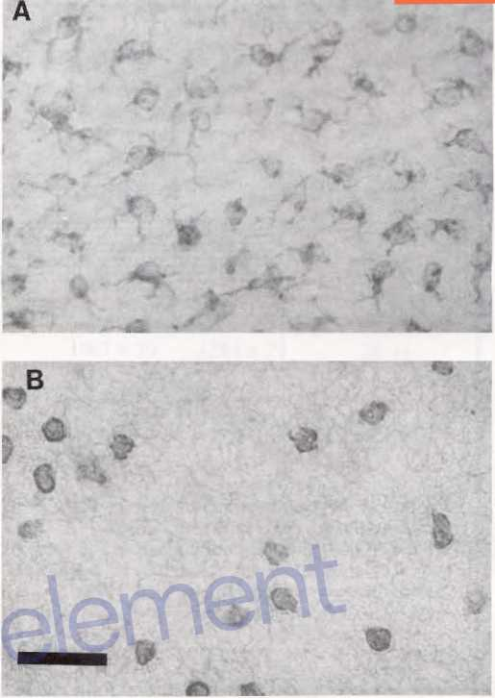Density of epidennal Langerhans cells NLDC- 145+ in healthy and ¿.mexicana-infected mice

**Remove Watermark Now**

Figure 2 Epidemial cells in EDTA-separated epidermis of BALB/c LmAman/a-infected mouse (3 weeks after infection). A. Langerhans cells; B Dendntic epidemial T cells. Avidin-biotin immunoperoxidase using anti NLDC-145 and Thy-1.2, respectivelv. Bar= lOpm.

***L. mexicana-infected*** BALB/c mice showed an increase in the numbers of epidemial NLDC-145+ LC, starting with valúes similar to those found in healthy mice (Table 1) and reaching maximal valúes between the 3rd (Fig. 2) and 5th weeks. These valúes start to decrease after the 9th week and reach normal valúes on the 1 Ith week. The difíerences between both groups showed statistically significant valúes after the 3rd week (Table 1).

***L.mexicana-mfected*** C57BL/6 mice showed a significant increase of LC the first 5 weeks after infection. On the 7th week, these valúes were lower than those observed in the healthy animáis, but remained within nomial ranges for the rest of the evaluation.

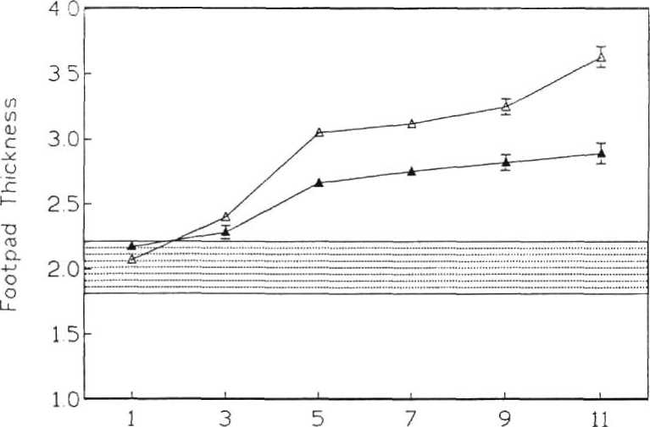

Weeks after infection

**Figure 1** Dcvclopment of cutaneous disease in ***Leishmania-mfcctcá*** mice BALB/c (A) and C57BL/6 (A) mice were inoculated in the footpad with 103 amastigotes of ***L. mexicana mexicana*** Footpads were measured every 2 weeks for 11 weeks, and the lesión size was determinad by sustractmg the left footpad thickness of healthy ammals fforn the inoculated left footpad thickness. The doted area represents the mean thickness of the footpads ffom healthy mice ± 2SEM Each pomt represents the mean of four mice.

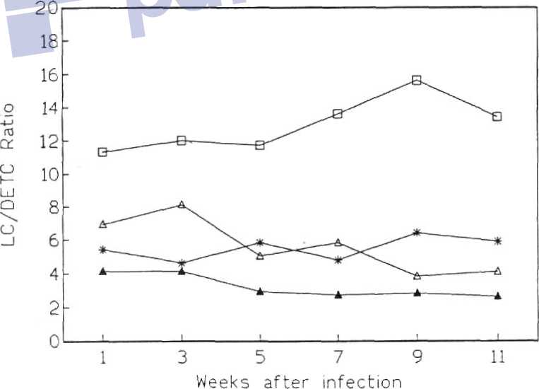

**Figure 3** Ratio between epidermal Langerhans cclls and Dendntic Epidermal T Cclls in ***Leishmania-mfected*** and healthy mice The experimental groups are healthy BALB/c (■).

healthy C57BL/6 (★), infected BALB/c (A) and infectéd C57BL/6 (A). Note that the valúes in healthy animáis are always higher than those for infectéd nuce.